**History of Operating System:**

**The First Generation (1940 to early 1950s)**

► When the first electronic computer was developed in 1940, it was created without any operating system.

► The programmer can perform and solve only simple mathematical calculations during the computer generation, and this calculation does not require an operating system.

**The Second Generation (1955 - 1965)**

► The first operating system (OS) was created in the early 1950s and was known as GMOS.

► General Motors has developed OS for the IBM computer. The second-generation operating system was based on a single stream batch processing system because it collects all similar jobs in groups or batches and then submits the jobs to the operating system using a punch card to complete all jobs in a machine.

► After that, new machines were called mainframes, which were very big and used by professional operators.

**The Third Generation (1965 - 1980)**

► During the late 1960s, operating system designers were very capable of developing a new operating system that could simultaneously perform multiple tasks in a single computer program called multiprogramming.

► The introduction of multiprogramming plays a very important role in developing operating systems that allow a CPU to be busy every time by performing different tasks on a computer at the same time.

► During the third generation, there was a new development of minicomputer's phenomenal growth starting in 1961 with the DEC PDP-1. These PDP's leads to the creation of personal computers in the fourth generation.

**The Fourth Generation (1980 - Present Day)**

► The fourth generation of operating systems is related to the development of the personal computer (PC).

► However, the personal computer is very similar to the minicomputers that were developed in the third generation.

► Windows OS was created in 1975.

► They introduced MS-DOS in 1981. (MS-DOS, in full Microsoft Disk Operating System, the dominant operating system for the personal computer (PC) throughout the 1980s. )

► Today, Windows has become the most popular and most commonly used operating system technology.

► And then, Windows released various operating systems such as Windows 95, Windows 98, Windows XP and the latest operating system, Windows 7.

► Currently, most Windows users use the Windows 10 operating system.

► Besides the Windows operating system, Apple is another popular operating system built in the 1980s, and this operating system was developed by Steve Jobs, a co-founder of Apple. They named the operating system Macintosh OS or Mac OS.

**Overview of Operating System:**

An Operating System is a program that manages the computer hardware. It also provides a basis for application programs and acts as an intermediary between the computer user and the computer hardware.

Inshort we can say, an Operating System (OS) is an interface between a computer user and computer hardware.

An operating system is a software which performs all the basic tasks like file management, memory management, process management, handling input and output, and controlling peripheral devices such as disk drives and printers.

E.g. of OS are –Windows, GNU/Linux, macOS (Macintosh) - used for Apple’s personal computers and workstations (MacBook, iMac), Android (Google’s Operating System for smartphones/tablets/smartwatches), iOS (Apple’s OS for iPhone, iPad and iPod Touch).

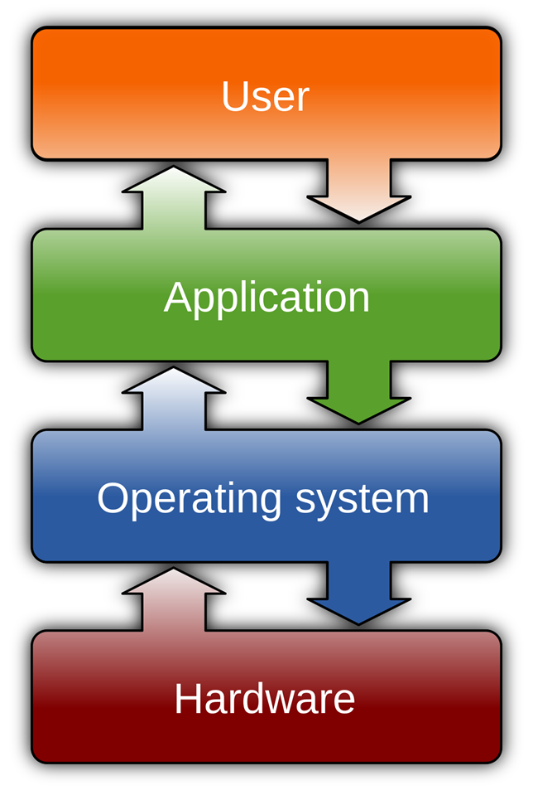 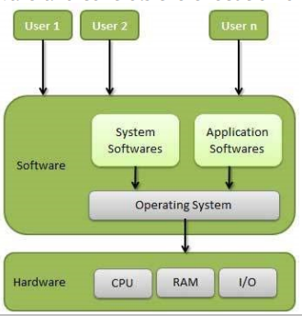

**Characteristics of Operating System:**

* **Memory Management** − Keeps track of the primary memory, i.e. what part of it is in use by whom, what part is not in use, etc. and allocates the memory when a process or program requests it.
* **Processor Management** − Allocates the processor (CPU) to a process and deallocates the processor when it is no longer required.
* **Device Management** − Keeps track of all the devices. This is also called I/O controller that decides which process gets the device, when, and for how much time.
* **File Management** − Allocates and de-allocates the resources and decides who gets the resources.
* **Security** − Prevents unauthorized access to programs and data by means of passwords and other similar techniques.
* **Job Accounting** − Keeps track of time and resources used by various jobs and/or users.
* **Interaction with the Operators** − Interaction may take place via the console of the computer in the form of instructions. The Operating System acknowledges the same, does the corresponding action, and informs the operation by a display screen.
* **Error-detecting Aids −** Production of dumps, traces, error messages, and other debugging and error-detecting methods.
* **Coordination Between Other Software and Users** − Coordination and assignment of compilers, interpreters, assemblers, and other software to the various users of the computer systems.

**Advantage and Disadvantage of OS:**

**Advantages:**

1. Easy to use with a GUI .
2. Offers an environment in which a user may execute programs/applications.
3. Acts as an intermediator between all hardware's and software's of the system.
4. Convenient: The operating system makes sure that the computer system is convenient to use.
5. Efficiency: OS allows computer system resources to be used in an efficient manner.
6. Allows you to hide details of hardware by creating an abstraction.

**Disadvantages:**

1. If any issue occurs in OS, you may lose all the contents which have been stored in your system.
2. Operating system's software is quite expensive for small size organization which adds burden on them. Example Windows.
3. It is never entirely secure as a threat can occur at any time.

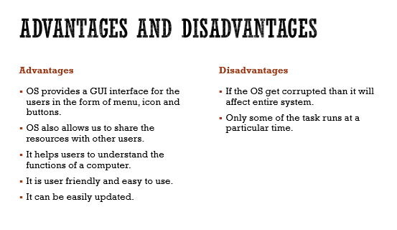

**System Software:**

System Software is a type of computer program that is designed to run a computer’s hardware and application program.

Inshort we can say, it acts as an interface between hardware and user applications.Interface is needed because hardware devices and humans speak in different languages.

English is the pre-dominant language of interacting with computers. System software converts all human instructions into machine understandable instructions.

Best example of System software is our Operating System.

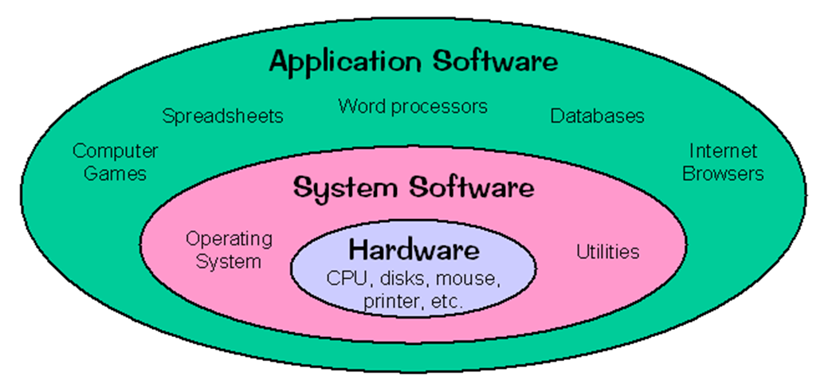

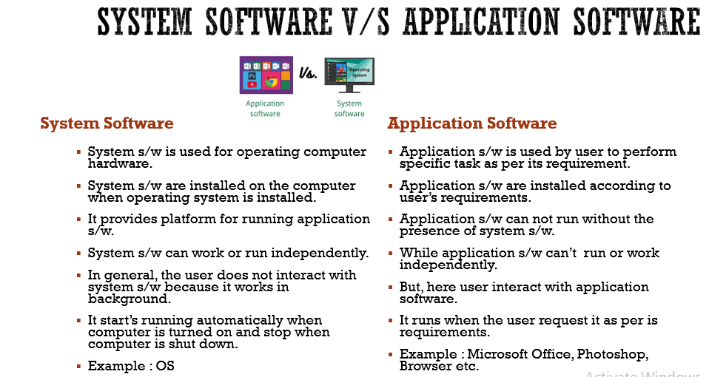

**Types of System Software:**

1. **Operating System-**

An operating system is system software that provides a platform between computer hardware, application software, and end-users. It is pre-installed on devices and allows them to be identified and then function. OS is the first thing to be loaded when a system is started.

1. **Device Drivers-**

System software that controls and monitors functioning of a specific device on

a computer.Each device that needs to be attached externally to the system has a specific

driver associated with it.When you attach a new device, you need to install its driver so that the OS knows it needs to be managed.

1. **BIOS-**

BIOS (Basic Input/Output System) gets the computer system started when we turn it on. BIOS also manages the flow of information between operating systems and the attached devices.

1. **Programming Language Translator-**

These are the intermediate system software through which programmers convert the high-level language programming code to machine-level language code. Assembler, Interpreter, and Compiler are the popular language translators. They are usually designed by the computer manufacturer and are deliver inbuilt with the system.

1. **Utilities-**

Utilities are the type of system software that is present between user and application software. These are the programs designed to configure, analyze, optimize and maintain tasks of the computer. Their task varies from disk fragmentation to data security.

